
CMR INSTITUTE OF TECHNOLOGY
ACADEMIC YEAR 2025-2026(EVENSEM)
Video Classroom REPORT
Department of Information Science and Engineering

Subject code | BIS601 | Course Name | Full Stack Development
Semester / Section | VI- B | Prepared By | Ms. Jayashree M
Curriculum Gap Identified: | NA

Summary of Video Classes Conducted:
Sl No. | Topic | Date | Duration | Total number of students
1 | DOM Components | 24/02/26 | 40 min | 40
2 | Express JS | 31/03/26 | 40 min | 30
3 | Mongo DB | 28/04/26 | 40 min | 40

Detailed Report
1 | DOM Components | Date : 24/02/26 | 40 min | No. of students: 40
Materials Shared Before Class

Full Stack Development material was shared with students through Google Class Room. The proof link of study Materials is shared in advance and the link is given below.
https://classroom.google.com/c/ODQyMzk5MDM3MTg4
Link to Videos
https://www.youtube.com/watch?v=hRaDYCHqFQQ
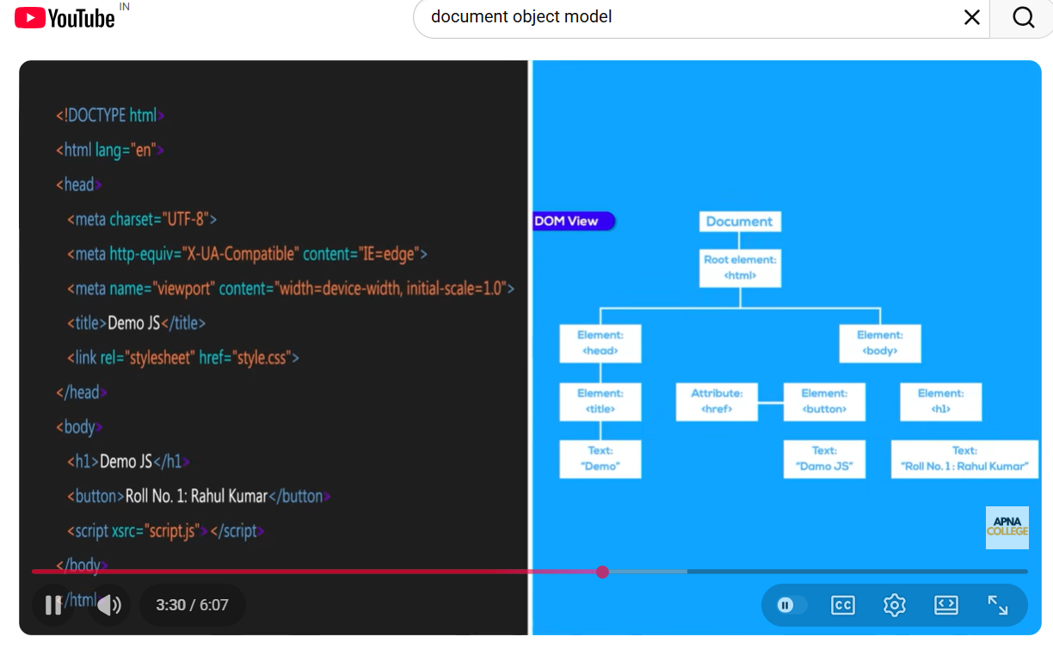
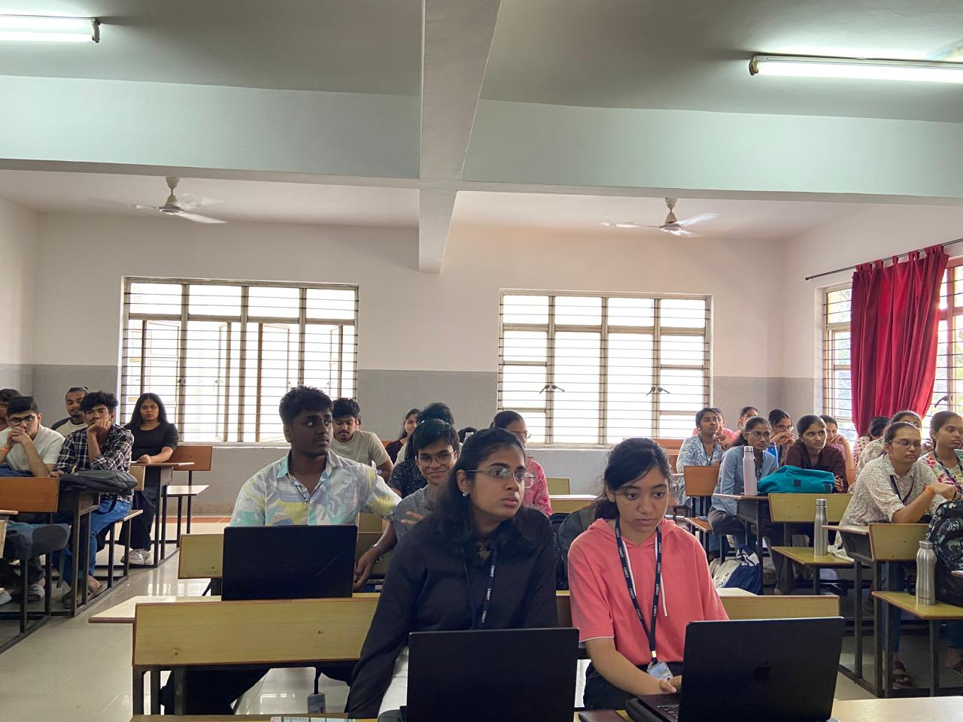

The DoM Components was explained to the students and able to understand the concept by seeing the example shown in video
Evaluation :
Outcome:
The outcome of this video session is:
The concept of Dom Components were explained n detail
The PO’s and PSO’s that are addressed by doing this flip class are as follows:
PO’s- 1,2,3,4,6,12
PSO’s- 1,2,3,4

2 | Express JS | Date : 31/03/26 | 45 minutes | No. of students: 30
Materials Shared Before Class

Full Stack Development material was shared with students through Google Class Room. The proof link of study Materials is shared in advance and the link is given below.
https://classroom.google.com/c/ODQyMzk5MDM3MTg4
Link to Videos

https://www.youtube.com/watch?v=0QRFOsrBtXw

Conduction of Video session on express js
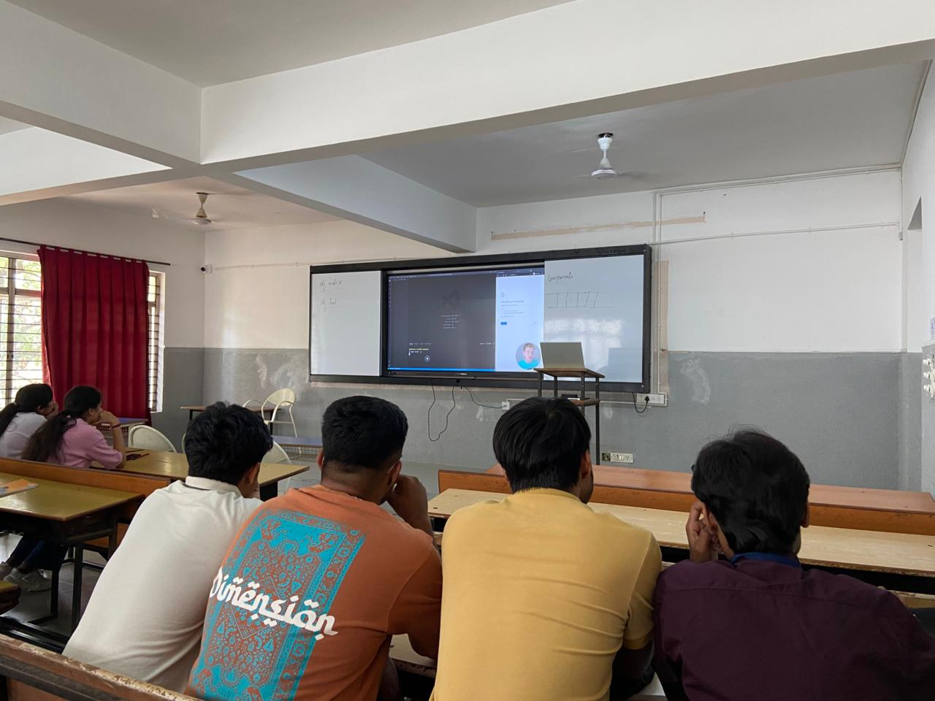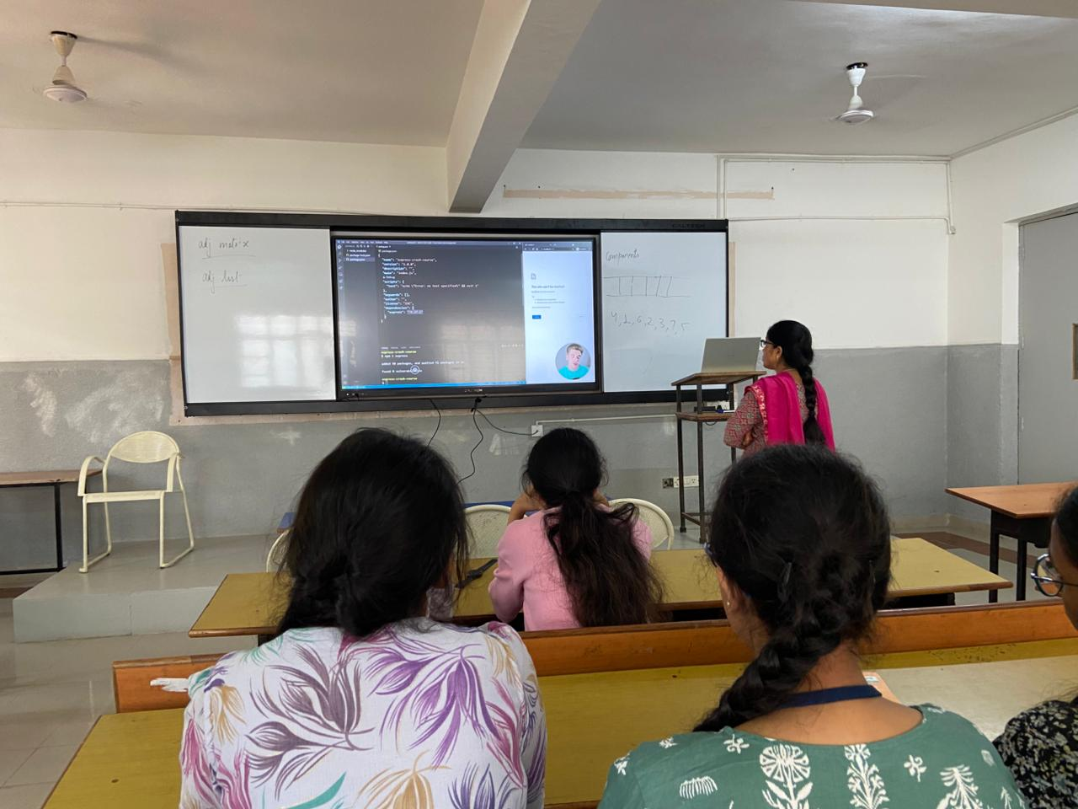
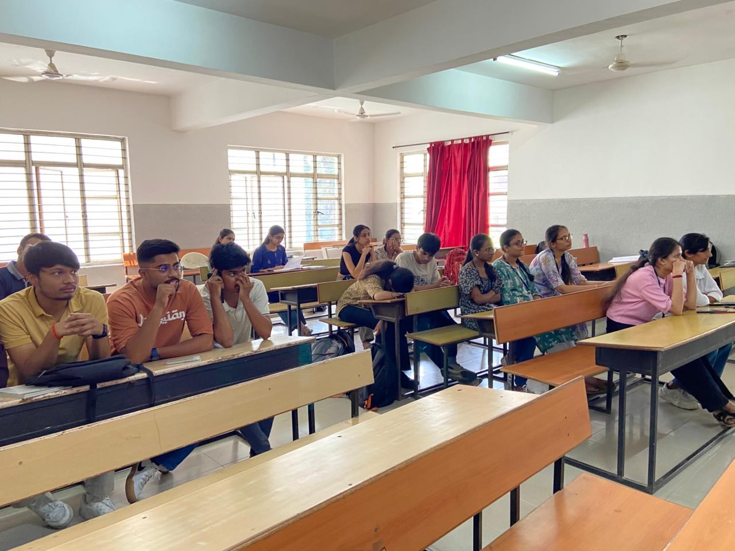
Introduction to Express Js was explained in simple steps

Evaluation :
Tested the students by asking the questions related to the explained concept and they were able to differentiate the different concept
Outcome:
The outcome of this session :
The environment of the ExpressJS
To push students to higher order blooms levels such as L2 and L3.
The PO’s and PSO’s that are addressed by doing this flip class are as follows:
PO’s- 1,2,3,4,6,12
PSO’s- 1,2,3,4
3 | Mango DB | Date: 28-04-2026 | 40 minutes | No. of students:40
Materials Shared Before Class
Full Stack Development material was shared with students through Google Class Room. The proof link of study Materials is shared in advance and the link is given below.
https://classroom.google.com/c/ODQyMzk5MDM3MTg4
Link to Videos

https://www.youtube.com/watch?v=70IAxFAt3xY&list=PLrJ-e9wsoQTEV1S53hpMp4D2oVLTUe3Ar

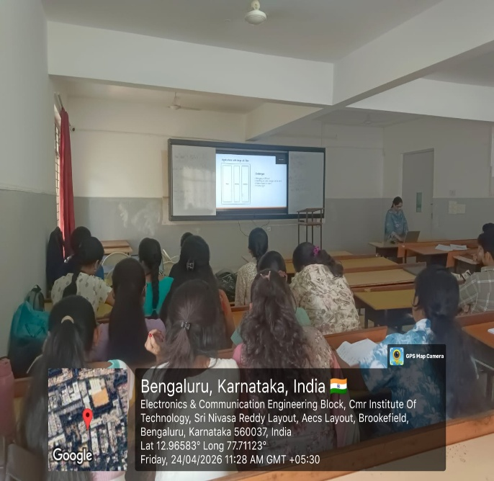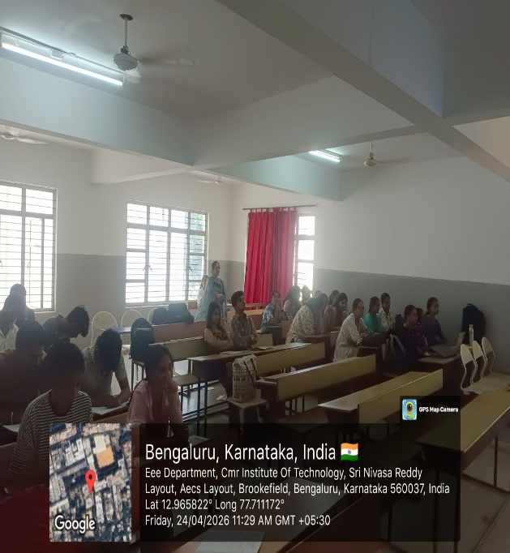
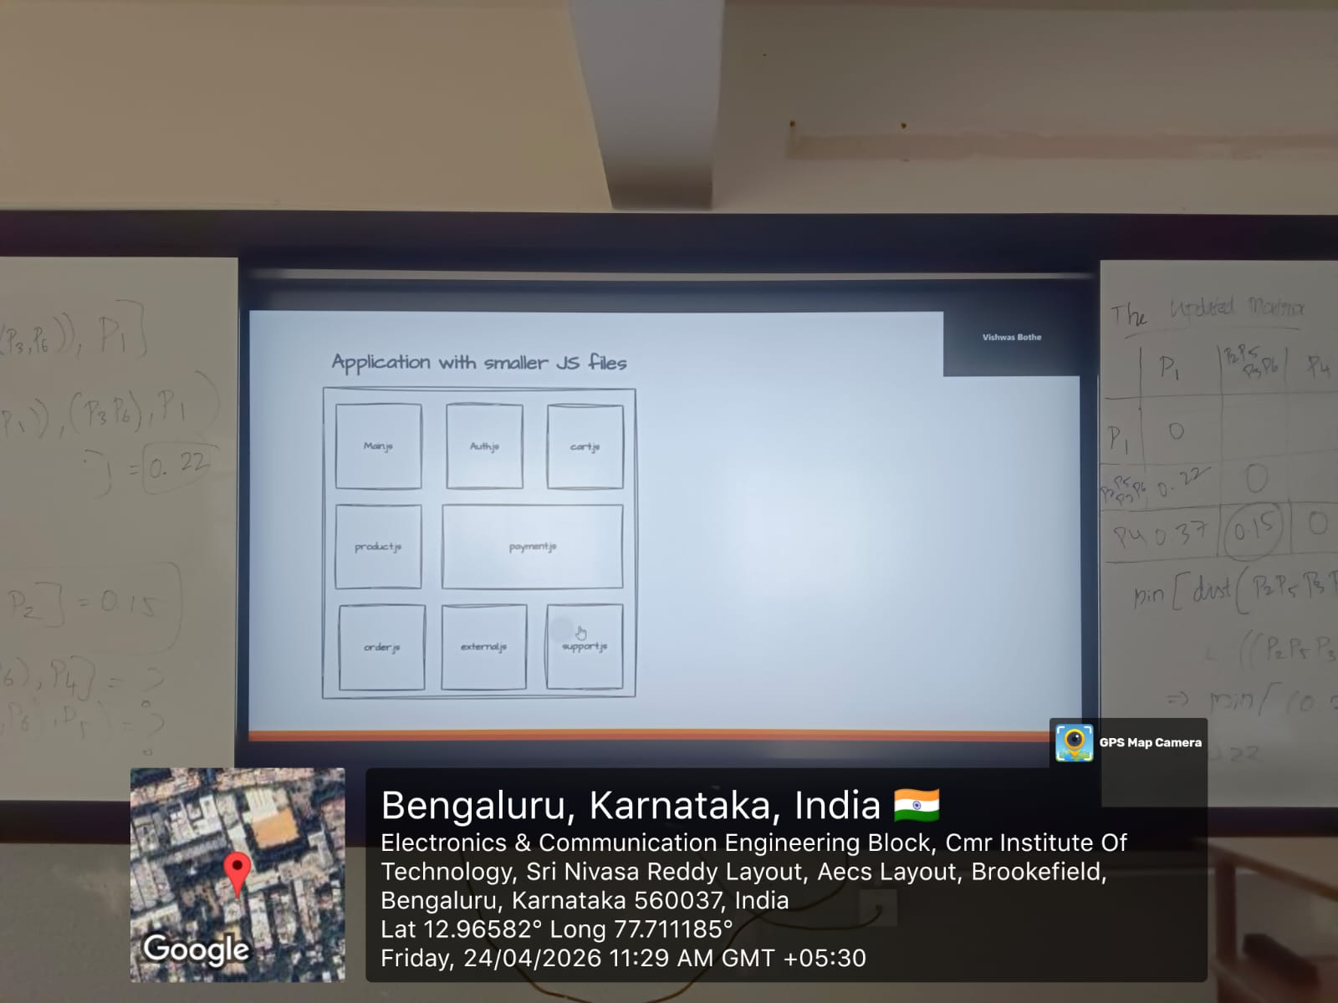

Students were able to understand the concept of Webpack and its importance
Outcome:
The outcome of this session :
The environment of the webpack
To push students to higher order blooms levels such as L2 and L3.
The PO’s and PSO’s that are addressed by doing this flip class are as follows:
PO’s- 1,2,3,4,6,12
PSO’s- 1,2,3,4

